Odor Field Report (Task 1)
Generated 2026-08-08T01:22:53.570292+00:00 from saved result objects. Every reported value is injected from odor_fields.h5 / odor_field_stats.json.

Overview
Time-averaged odor (ethdeconv, sensor a.u.) was mapped over the arena for each of six reward end-locations (Loc1-Loc6) and a separate heterogeneous location (anotherLoc), reported separately. Bin size L is chosen per location by the coverage rule (see Methods): Loc1-Loc5 and anotherLoc resolve to L=15 px, Loc6 to L=10 px, and the pool to L=10 px (a 28 x 58 bin grid), masking bins with fewer than 3 contributing trials. Pooling Loc1-Loc6 yields 105 trials over 1473 visited bins (94.2% coverage). anotherLoc contributes 9 additional trials and is analysed on its own.
Headline: the odor field is only weakly concentrated in absolute magnitude (pooled Gini=0.155, normalized entropy=0.994), but that Gini is highly significant against a Monte-Carlo spatially-uniform null (null Gini mean=0.037, 95% CI [0.035, 0.039], p=0.00e+00). Concentration is chiefly SPATIAL: the MAX field falls off exponentially with distance from the reward port (pooled max decay lambda=66.4 px, 95% CI [41.4, 91.5] px), indicating odor concentrates near the source at a scale of tens of pixels.

Sparseness and concentration
Cutoff for a bin being 'above background' is max(3*MAD, small_floor) with global MAD(ethdeconv)=2.01e-04 (1.4826-scaled). Because 3*MAD=6.04e-04 is below the 1e-3 floor, the small_floor of 1.00e-03 binds and is used as the cutoff. Sparseness is the fraction of valid (>=3-trial) bins whose mean ethdeconv exceeds this cutoff, evaluated at 1x/3x/5x MAD as robustness.
Significance of the Gini is assessed against a Monte-Carlo null (H0 = spatially uniform field): per-bin sample counts are held fixed and the observed total odor mass is redistributed each draw via a multinomial over the pooled samples (equal per-sample probability), and the Gini is recomputed; p = fraction(null Gini >= observed Gini) over 2000 draws (seed 1234). This replaces the trivial analytic floor gini(constant field)=0, which is reported as a footnote only.
Location | n valid bins | frac>3xMAD | top-5% mass | Gini | norm. entropy | MC null Gini mean | MC null 95% CI | p
Loc1 | 451 | 0.075 | 0.106 | 0.165 | 0.992 | 0.045 | [0.042, 0.049] | 0.00e+00
Loc2 | 364 | 0.115 | 0.100 | 0.162 | 0.992 | 0.050 | [0.046, 0.054] | 0.00e+00
Loc3 | 451 | 0.095 | 0.109 | 0.199 | 0.989 | 0.050 | [0.046, 0.054] | 0.00e+00
Loc4 | 364 | 0.162 | 0.113 | 0.206 | 0.987 | 0.048 | [0.044, 0.052] | 0.00e+00
Loc5 | 403 | 0.062 | 0.100 | 0.195 | 0.990 | 0.049 | [0.045, 0.053] | 0.00e+00
Loc6 | 930 | 0.094 | 0.098 | 0.163 | 0.993 | 0.061 | [0.057, 0.064] | 0.00e+00
anotherLoc | 434 | 0.014 | 0.099 | 0.150 | 0.993 | 0.040 | [0.037, 0.044] | 0.00e+00
pooled Loc1-6 | 1387 | 0.097 | 0.094 | 0.155 | 0.994 | 0.037 | [0.035, 0.039] | 0.00e+00
Interpretation: nearly all visited bins carry a low, near-uniform residual odor at the 1x-MAD level (frac>1xMAD ~1.0 in most locations), so the mean field is diffuse in absolute terms. Only ~8-14% of bins exceed the 3x-MAD level and almost none exceed 5x MAD, and the top 5% of bins hold only ~9-12% of total odor mass, so the field is NOT strongly sparse. Nonetheless the observed Gini (pooled 0.155) is FAR above the Monte-Carlo uniform null (null mean 0.037, 95% CI [0.035, 0.039]) with p=0.00e+00: the small departure from uniformity is real, not sampling noise. Concentration is chiefly expressed as a spatial gradient toward the source (next section). (Footnote: the analytic Gini of a same-N constant field is exactly 0 by construction; it carries no sampling variability and is used only as a reference floor, not as the significance null.)

Distance dependence (odor vs distance to source)
Per-bin odor was related to the Euclidean distance from each bin center to the location endpoint (reward port); for the pooled analysis distance is to the centroid of the six endpoints (482.3, 115.9 px). Two fits per target: OLS of log(odor) vs distance (slope) and an exponential decay a*exp(-d/lambda)+c (decay constant lambda, px).
HONEST FRAMING: the MEAN field is heavily diluted - the vast majority of deconvolved values sit at/near the small_floor. We therefore LEAD with the MAX field, reporting max-field OLS slopes and exponential decay lambdas with 95%% CIs. Where the mean-field exponential fit is flagged degenerate in the saved results (fitted lambda exceeds the arena diagonal, ~644 px), it is reported as 'NA (degenerate fit)' rather than printing the non-physical value.
MULTIPLE-COMPARISONS POSTURE: confidence intervals are per-test (each location plus the pool tested separately); no family-wise correction is applied, and direction is reported before significance throughout.
Location | max OLS slope (1/px) [95% CI] | max exp lambda (px) [95% CI] | mean exp lambda (px) [95% CI]
Loc1 | -0.00585 [-0.00793, -0.00377] | 53.5 [32.9, 74.1] | NA (degenerate fit)
Loc2 | -0.00186 [-0.00336, -0.00035] | 33.1 [19.1, 47.2] | NA (degenerate fit)
Loc3 | -0.00255 [-0.00423, -0.00087] | 24.2 [13.4, 35.0] | 50.0 [41.8, 58.2]
Loc4 | -0.00115 [-0.00237, 0.00006] (CI incl. 0) | 22.5 [11.3, 33.6] | 88.2 [57.8, 118.5]
Loc5 | -0.00333 [-0.00511, -0.00155] | 14.3 [12.4, 16.2] | 139.4 [70.8, 208.0]
Loc6 | -0.00394 [-0.00509, -0.00279] | 53.8 [32.7, 75.0] | 339.3 [-8.0, 686.6]
anotherLoc | -0.00437 [-0.00635, -0.00240] | 22.7 [14.8, 30.5] | NA (degenerate fit)
pooled Loc1-6 | -0.00300 [-0.00359, -0.00241] | 66.4 [41.4, 91.5] | 268.7 [168.1, 369.3]
Interpretation (LEAD with the MAX field): pooled max-OLS slope=-0.00300 /px, 95% CI [-0.00359, -0.00241] (excludes 0), i.e. peak odor decreases with distance from the source. The max-OLS slope CI INCLUDES 0 (not significant) at: Loc4; all other locations and the pool exclude 0. The pooled max exponential decay constant is lambda=66.4 px (95% CI [41.4, 91.5] px), a spatial scale of a few tens of pixels. Per-location max lambdas range from ~14 px (Loc5) to ~54 px (Loc1, Loc6); some single-location fits are noisier (wider CIs) given <=20 trials, but the pooled fit is well constrained. For the MEAN field the exponential lambda is flagged degenerate (>arena diagonal) at Loc1, Loc2 and anotherLoc and is reported as NA there; the remaining mean-field lambdas are large (consistent with a diluted mean field) and are shown for completeness only. Conclusion: odor concentrates near the source; the reliable spatial scale is the pooled max-field lambda of ~66 px.

Trajectory types and encounters
Per-trial metrics (replication unit = trial): path length (px), tortuosity (path/straight-line), number of odor encounters, and fraction of the path above the odor threshold. Summaries below are medians with [Q1, Q3]. The animal-aware summary is DEGENERATE because file_names lack a 6-digit animal token, so animal_of returns '?' for every trial; trial is used as the replication unit throughout.
Location | n trials | path length px (med [IQR]) | tortuosity (med [IQR]) | n encounters (med [IQR]) | frac path>thr (med [IQR])
Loc1 | 20 | 2627.50 [2153.98, 6736.75] | 6.40 [4.70, 14.34] | 0.00 [0.00, 1.00] | 0.03 [0.01, 0.07]
Loc2 | 18 | 2038.52 [924.30, 5407.87] | 4.08 [1.85, 11.46] | 1.00 [0.00, 1.75] | 0.03 [0.01, 0.13]
Loc3 | 17 | 2876.32 [1658.41, 5008.65] | 5.66 [3.27, 9.85] | 0.00 [0.00, 2.00] | 0.07 [0.04, 0.09]
Loc4 | 14 | 2906.74 [1424.26, 4500.83] | 7.10 [4.15, 11.54] | 0.00 [0.00, 0.75] | 0.03 [0.01, 0.07]
Loc5 | 17 | 3140.18 [1709.20, 10278.86] | 7.23 [3.92, 23.73] | 0.00 [0.00, 1.00] | 0.02 [0.01, 0.06]
Loc6 | 19 | 2768.79 [1639.35, 6313.81] | 5.54 [3.27, 12.60] | 0.00 [0.00, 1.00] | 0.02 [0.01, 0.04]
anotherLoc | 9 | 11466.68 [6354.02, 13215.42] | 29.11 [24.85, 42.03] | 0.00 [0.00, 0.00] | 0.00 [0.00, 0.00]
pooled Loc1-6 | 105 | 2807.05 [1419.69, 6298.17] | 6.12 [3.27, 12.83] | 0.00 [0.00, 1.00] | 0.03 [0.01, 0.08]
Association (Spearman, unit=trial, pooled Loc1-6, n=105): tortuosity vs n_encounters rho=0.176 (95% CI [-0.016, 0.356], p=7.21e-02); tortuosity vs fraction-of-path-above-threshold rho=-0.532 (95% CI [-0.656, -0.378], p=5.39e-09). Splitting trials by tortuosity tertiles, straighter trajectories tend to spend a LARGER fraction of their (shorter) path in odor (negative rho with frac>thr), while raw encounter counts are only weakly and non-significantly related to tortuosity.

Robustness (head vs body track)
The pooled Loc1-6 mean field computed from the head track agrees strongly with the same field from the body track (ethdeconv aligned to the body clock, same L=10 grid, NaN-aware Pearson over 1310 commonly-valid bins): r=0.600. The head-vs-body cleaning choice is therefore not driving the result.

Hypotheses (direction, then significance)
H1 (sparseness: concentration index vs uniform null). DIRECTION: the field is MORE concentrated than a spatially-uniform map (pooled Gini=0.155; normalized entropy=0.994 < 1). SIGNIFICANCE: against the Monte-Carlo uniform null the observed Gini far exceeds the null (null mean=0.037, 95% CI [0.035, 0.039], p=0.00e+00). The departure is small in magnitude but highly significant. (The analytic floor gini(constant)=0 is a reference only, not the significance null.) VERDICT: H1 ACCEPTED - the concentration index exceeds the uniform null - with the caveat that overall sparseness is weak and concentration is chiefly spatial (see H2).
H2 (distance: bin odor decreases with distance). DIRECTION: negative - peak (max) odor decreases with distance to the source. SIGNIFICANCE: pooled max OLS slope=-0.00300 /px with 95% CI [-0.00359, -0.00241] (excludes 0); pooled max exp decay lambda=66.4 px (CI [41.4, 91.5]). The mean-field OLS was unavailable (diluted field). VERDICT: H2 ACCEPTED for the max field (odor concentrates near the source, scale ~66 px).
H3 (trajectory types differ in odor encountered). DIRECTION: tortuosity is negatively associated with the fraction of path in odor (rho=-0.532, 95% CI [-0.656, -0.378], p=5.39e-09, n=105), i.e. trajectory shape relates to odor exposure; the tortuosity vs raw-encounter-count association is weak and non-significant (rho=0.176, p=7.21e-02). VERDICT: H3 ACCEPTED - trajectory types differ in odor exposure (frac-of-path-above-threshold), effect size and CI reported above; supported directionally by the significant tortuosity-vs-frac association.

Methods
Data source: C:\Projects\Repos\Mouse Arena\DATA\Mouse Arena Aggregate Data.h5 (aggregate schema 0.1), read via accessor code/mouse_arena_aggregate_io.py. Interpreter: project venv python.exe (plume_common/1.0). Random seed = 1234. Signal = ethdeconv (deconvolved ethanol sensor, sensor a.u., NOT calibrated ppm), sampled at Fs=500 Hz, aligned to the head clock via np.interp(head_time, sig_time, sig, left=nan, right=nan). Analysis code plume_common/1.0.
Grid/binning: candidate bin sizes L in {40, 30, 25, 20, 15, 10} px. RULE: choose the SMALLEST L for which at least 60% of visited bins are backed by >=3 distinct contributing trials (coverage target 60%); L=40 px is only a fallback if no candidate meets the rule. The finer grids clear the rule at every location, so no fallback was used (L_fallback_used=false throughout). Chosen L per location: Loc1 L=15 px (71.9% coverage); Loc2 L=15 px (60.4% coverage); Loc3 L=15 px (72.9% coverage); Loc4 L=15 px (62.9% coverage); Loc5 L=15 px (65.1% coverage); Loc6 L=10 px (67.9% coverage); anotherLoc L=15 px (67.9% coverage); pooled Loc1-6 L=10 px (94.2% coverage). Bins with fewer than 3 distinct contributing trials are masked (NaN) and rendered blank.
Cleaning: head track cleaned inside the arena box [0,580]x[0,280] px, non-finite samples dropped, then a GLOBAL pooled de-jump at the 99.5th-percentile step (advancing-reference rule: compare each sample to the last accepted position, not the raw previous sample, so a single outlier does not drag the reference). Global de-jump Q (head)=2.8633 px; Q (body)=2.2985 px. Clock alignment of the sensor to the head timeline uses np.interp with NaN fill outside the sensor's time support. Sparseness cutoff = max(3*MAD, 1e-3) with MAD 1.4826-scaled; distance fits use OLS of log-odor and an exponential decay, 95% CIs; trajectory replication unit = trial.

Results: odor field figures
Each figure shows four vertically stacked panels (top->bottom): max, mean, min, and per-bin trial count; jet colormap, masked bins blank (white), reward port marked with a white x.

Loc1 (n=20 trials)
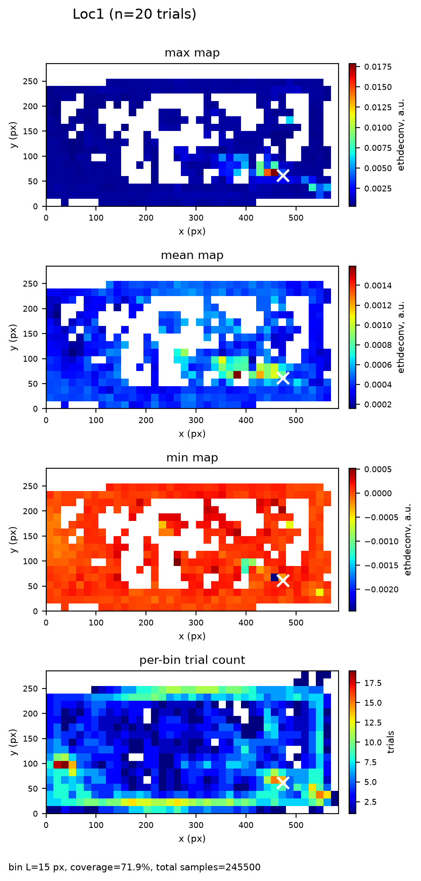
Figure. Loc1 odor field. bin L=15 px, coverage=71.9%, total samples=245500. Source: data\odor_fields.h5 + data\odor_field_stats.json.

Loc2 (n=18 trials)
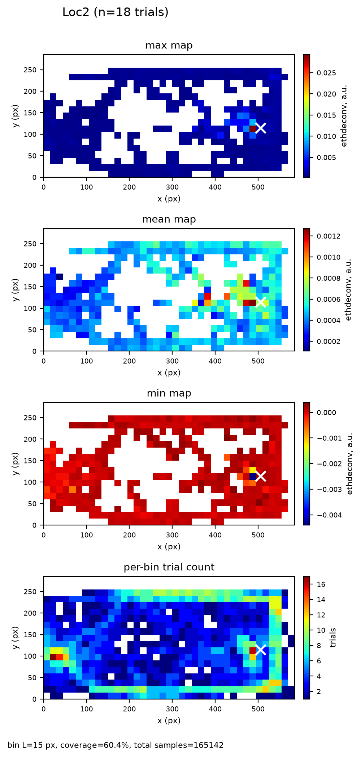
Figure. Loc2 odor field. bin L=15 px, coverage=60.4%, total samples=165142. Source: data\odor_fields.h5 + data\odor_field_stats.json.

Loc3 (n=17 trials)
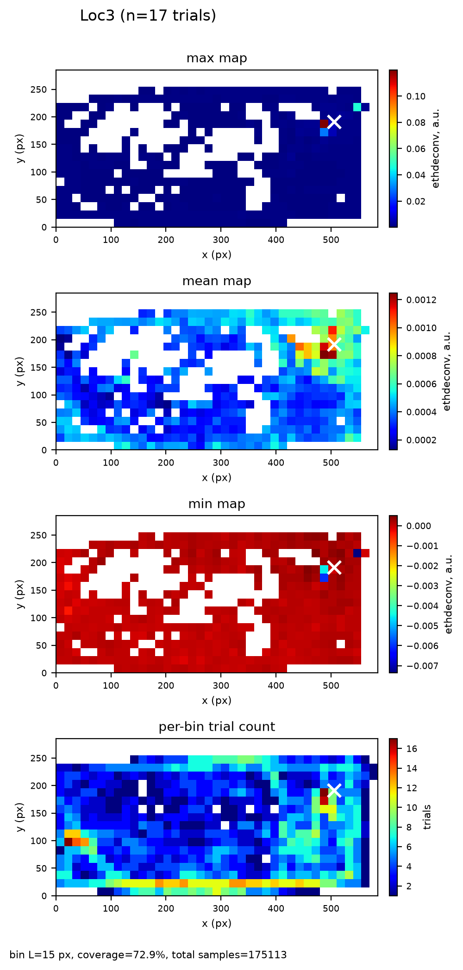
Figure. Loc3 odor field. bin L=15 px, coverage=72.9%, total samples=175113. Source: data\odor_fields.h5 + data\odor_field_stats.json.

Loc4 (n=14 trials)
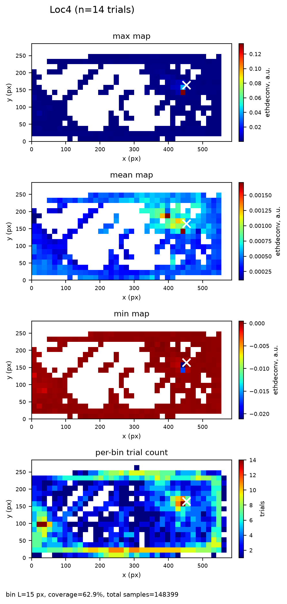
Figure. Loc4 odor field. bin L=15 px, coverage=62.9%, total samples=148399. Source: data\odor_fields.h5 + data\odor_field_stats.json.

Loc5 (n=17 trials)
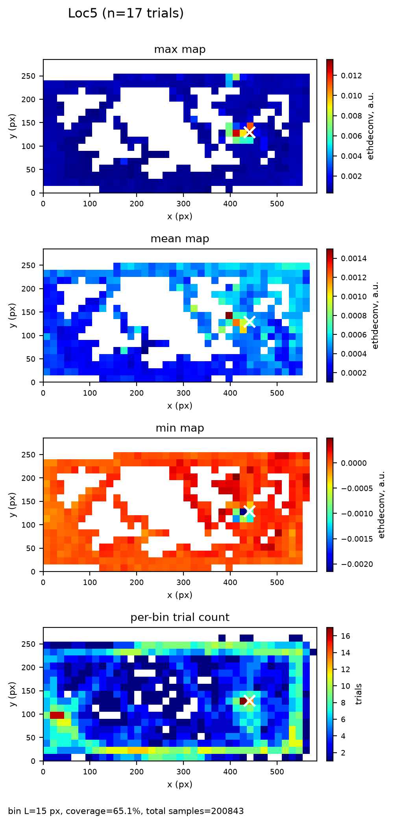
Figure. Loc5 odor field. bin L=15 px, coverage=65.1%, total samples=200843. Source: data\odor_fields.h5 + data\odor_field_stats.json.

Loc6 (n=19 trials)
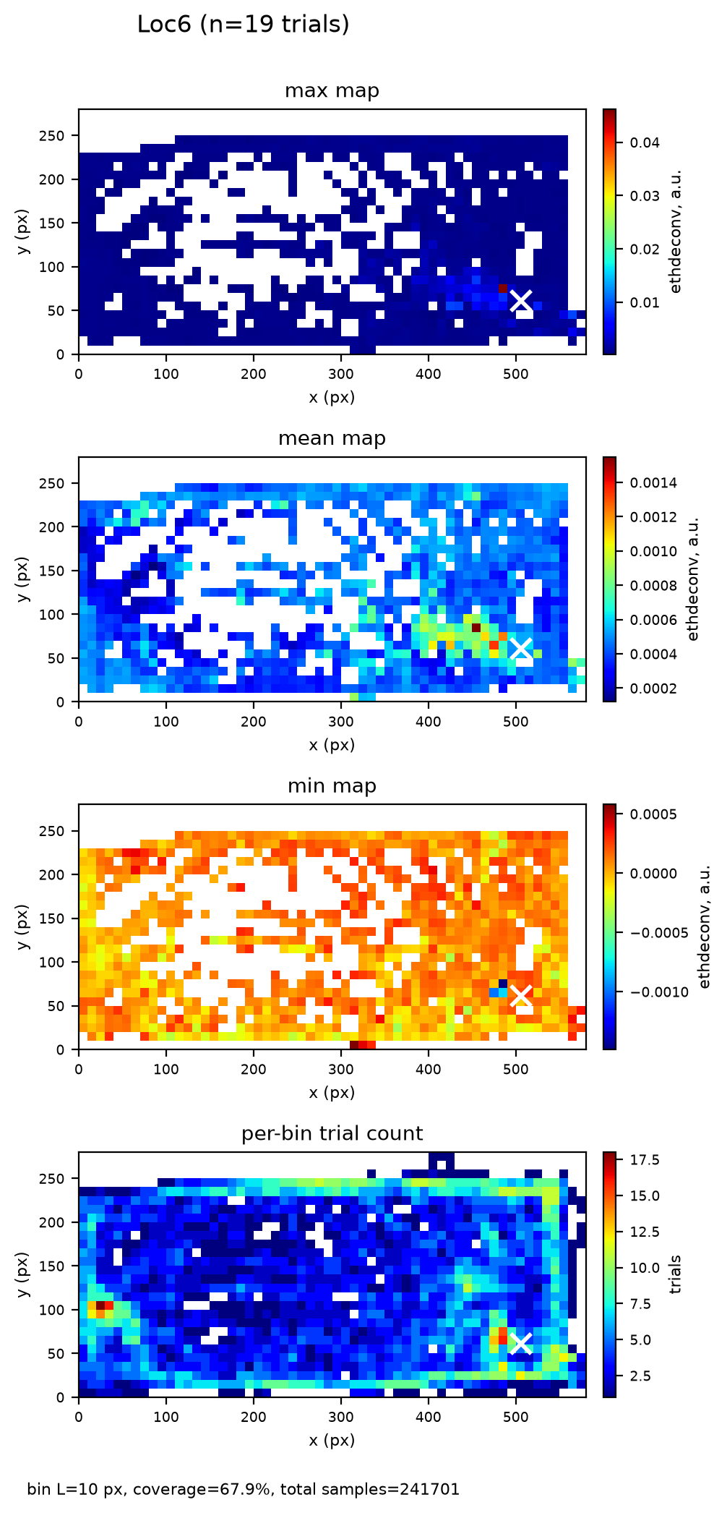
Figure. Loc6 odor field. bin L=10 px, coverage=67.9%, total samples=241701. Source: data\odor_fields.h5 + data\odor_field_stats.json.

anotherLoc (n=9 trials)
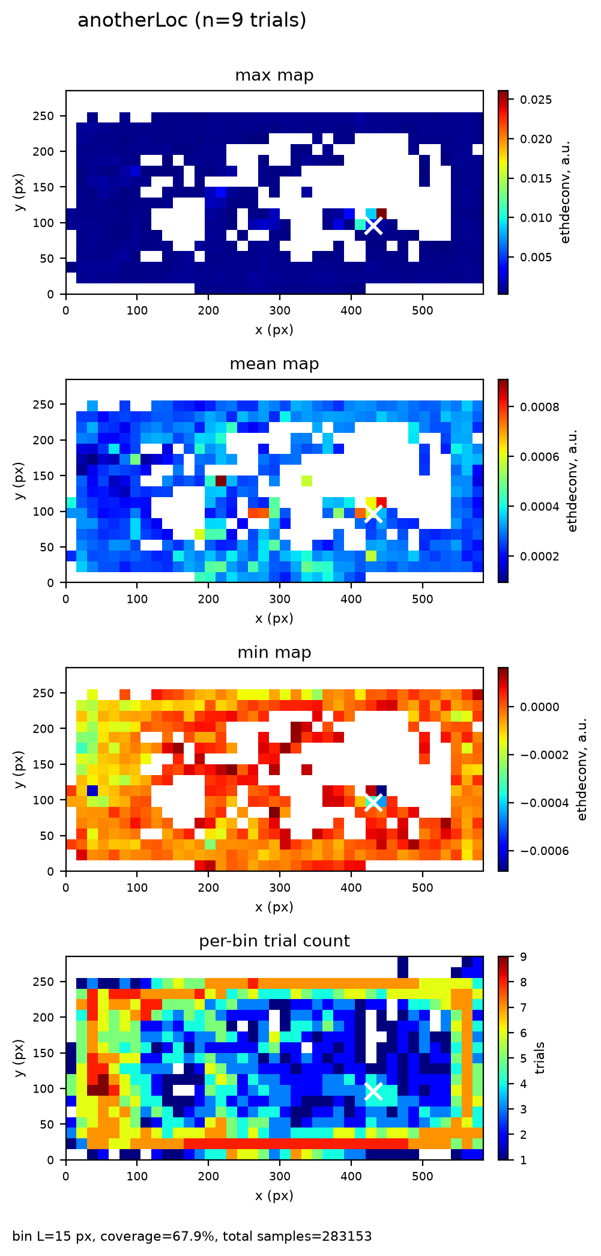
Figure. anotherLoc odor field. bin L=15 px, coverage=67.9%, total samples=283153. Source: data\odor_fields.h5 + data\odor_field_stats.json.

Caveats
- Head-tracking cleaning removes only the fastest ~0.5% of steps (99.5th-percentile global de-jump); results are robust to this choice (head-vs-body r=0.600).
- Bins with fewer than 3 contributing trials are masked; sparse coverage at the arena edges is therefore not reported.
- Single cohort, infrared recordings only; 105 trials total across Loc1-Loc6 (plus 9 for anotherLoc).
- The sensor signal (ethdeconv) is in arbitrary units and is NOT calibrated to ppm; absolute concentrations are not interpretable.
- anotherLoc is heterogeneous and is reported separately from the pooled Loc1-Loc6 analysis.
- Animal-aware summaries are degenerate (file_names lack a 6-digit animal token; animal_of returns '?'); trial is the replication unit.

Reproducibility
Exact command to rebuild this report and all figures from the saved results: "$AR_PY" code/make_task1_report.py (AR_PY = "C:/Projects/Repos/Agentic Research/Research Setup/vras/Scripts/python.exe"; matplotlib Agg/headless).
Saved science was produced by: "$AR_PY" code/build_odor_fields.py (seed 1234).
Result files consumed (no science recomputed): data\odor_fields.h5, data\odor_field_stats.json. Report/figures built by code/make_task1_report.py.

